**Convert .java file to .exe**

**Eclipse:**

1. 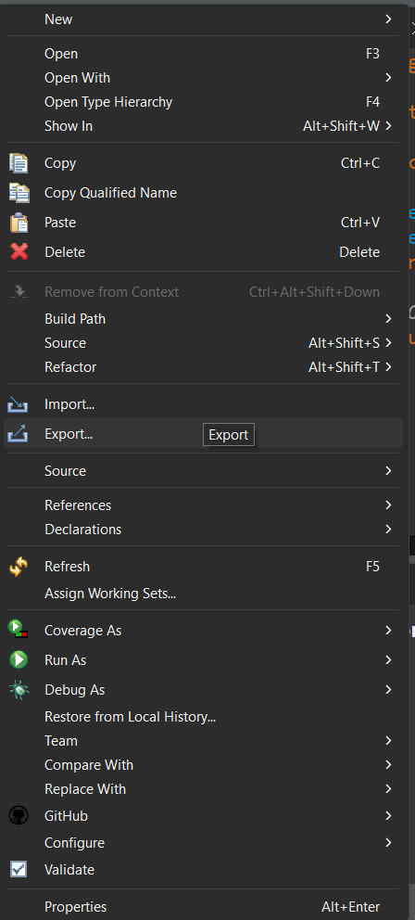Click the main java file of project
2. 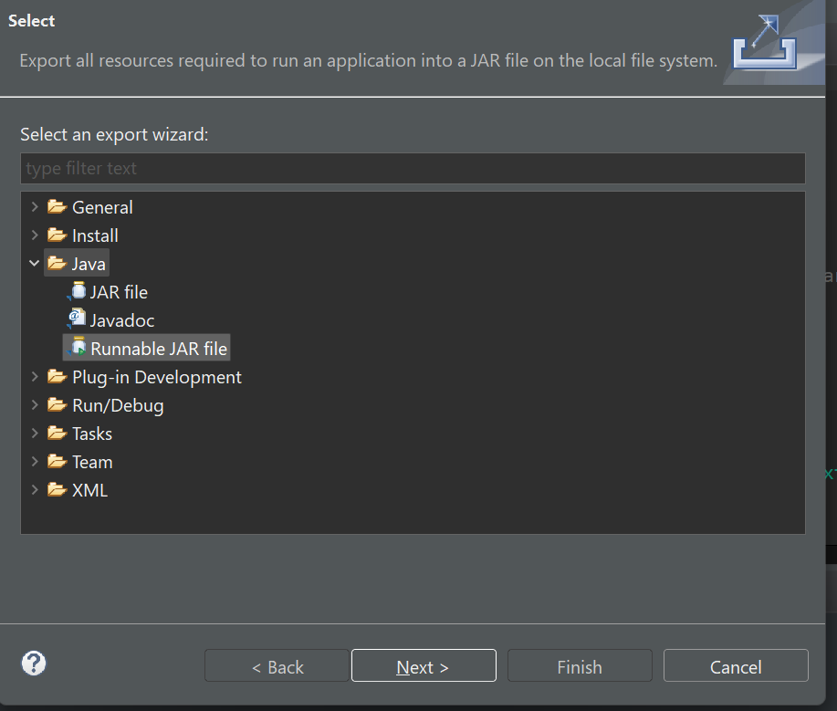Then right click and export
3. 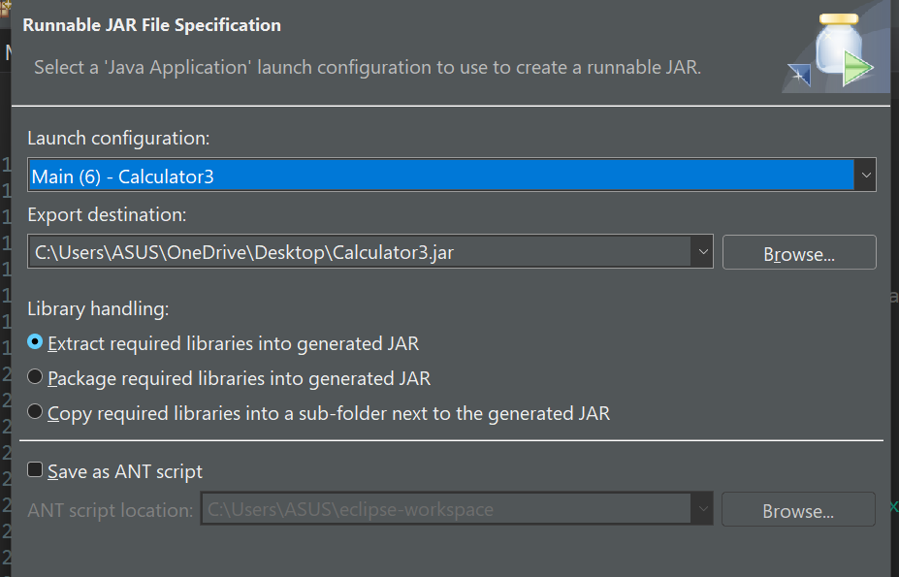Runnable JAR file
4. Launch configuration select the main project
5. Export destination where create jar files
6. 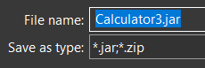when select export destination then file name as .jar extention
7. Library handling first option select alltime
8. Now finish and jar file created your selected location

**Steps to Create the Shortcut:**

1. Right-click on your desktop or in any folder and select New > Shortcut.
2. Enter the command above in the location field.
3. Click Next, give the shortcut a name (e.g., "Calculator App"), and click Finish.
4. Now, you can double-click this shortcut to launch your JavaFX application directly.

⭐️⭐️⭐️**RUN JAR FILES**⭐️⭐️⭐️

**Command prompt:**

"C:\Program Files\Java\jdk-23\bin\javaw.exe" --module-path "C:\Users\ASUS\JAVA\javafx-sdk-23.0.1\lib" --add-modules javafx.controls,javafx.fxml -jar **"C:\Users\ASUS\OneDrive\Desktop\Calculator3.jar"**

where in last just change which jar files you to update that's path

Note: Ensure your path is include "" apostrope and .jar files

1. At first open desktop

2. Save the jar file in desktop

3. Right click jar files and copy files path

4. Right click then show more and in last Create Shortcut

5. Now right click the shortcut files and show more to properties

6. Select Shortcut menu

7. Target option

8. Mentioned previous command where just change this jar files path

9. Apply

10. Now if i double click this shortcut file it will be run smoothly

**Launch4j**

⭐️⭐️**Main Class**⭐️⭐️

packageName.MainClassName

ex. application.Main

⭐️⭐️**Classpath javafx jar files**⭐️⭐️

javafx.base.jar

javafx.controls.jar

javafx.fxml.jar

javafx.graphics.jar

javafx.media.jar

javafx.swing.jar

javafx.web.jar

javafx-swt.jar

⭐️⭐️**JRE**⭐️⭐️

**JRE paths:**

C:\Program Files\Java\jdk-23

**Min JRE version:**

17

**JVM options:**

--module-path "C:\Users\ASUS\JAVA\javafx-sdk-23.0.1\lib" --add-modules javafx.controls,javafx.fxml,javafx.graphics

**Environment var:**

PATH: C:\Program Files\Java\jdk-23\bin

**Note:**

1. 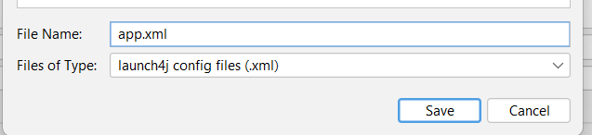After setup all form then click Build Wrapper (settings icon)
2. Save file .xml extension
3. Then click Test Wrapper (Run Icon)

**If you successfully setup your program then it's run smoothly!**

**Final Look is below:**

